**DAILY ONLINE ACTIVITIES SUMMARY**

|  |  |  |  |  |  |
| --- | --- | --- | --- | --- | --- |
| **Date:** | | **20/06/2020** | **Name:** | **JASLINE SHARON TAURO** | |
| **Sem & Sec** | | **4th sem, A Section** | **USN:** | **4AL18CS029** | |
| **Online Test Summary** | | | | | |
| **Subject** | **DATA COMMUNICATION** | | | | |
| **Max. Marks** | **30** | | **Score** | **19** | |
| **Certification Course Summary** | | | | | |
| **Course** | | Software development engineer | | | |
| **Certificate Provider** | | **AWS Educate** | **Duration** | | **4 hrs.** |
| **Coding Challenges** | | | | | |
| **Problem Statement:**   1. Write a Java program to count number of bits to be flipped to convert A to B. 2. Write a C Program to rotate an array by K positions. | | | | | |
| **Status: EXECUTED** | | | | | |
| **Uploaded the report in GitHub** | | | **YES** | | |
| **If yes Repository name** | | | <https://github.com/jaslinesharontauro/JAVA_Prgms>  <https://github.com/jaslinesharontauro/C_Prgms> | | |
| **Uploaded the report in slack** | | | **YES** | | |

Online Test Details: (Attach the snapshot and briefly write the report for the same)

Certification Course Details: (Attach the snapshot and briefly write the report for the same)

Coding Challenges Details: (Attach the snapshot and briefly write the report for the same)

ONLINE TEST:

Today we had assessment on the subject “DATA COMMUNICATION”. The test was based on Third and Fourth module of this subject. The test was comprised of 30 questions of ONE mark each, out of which I scored 19.

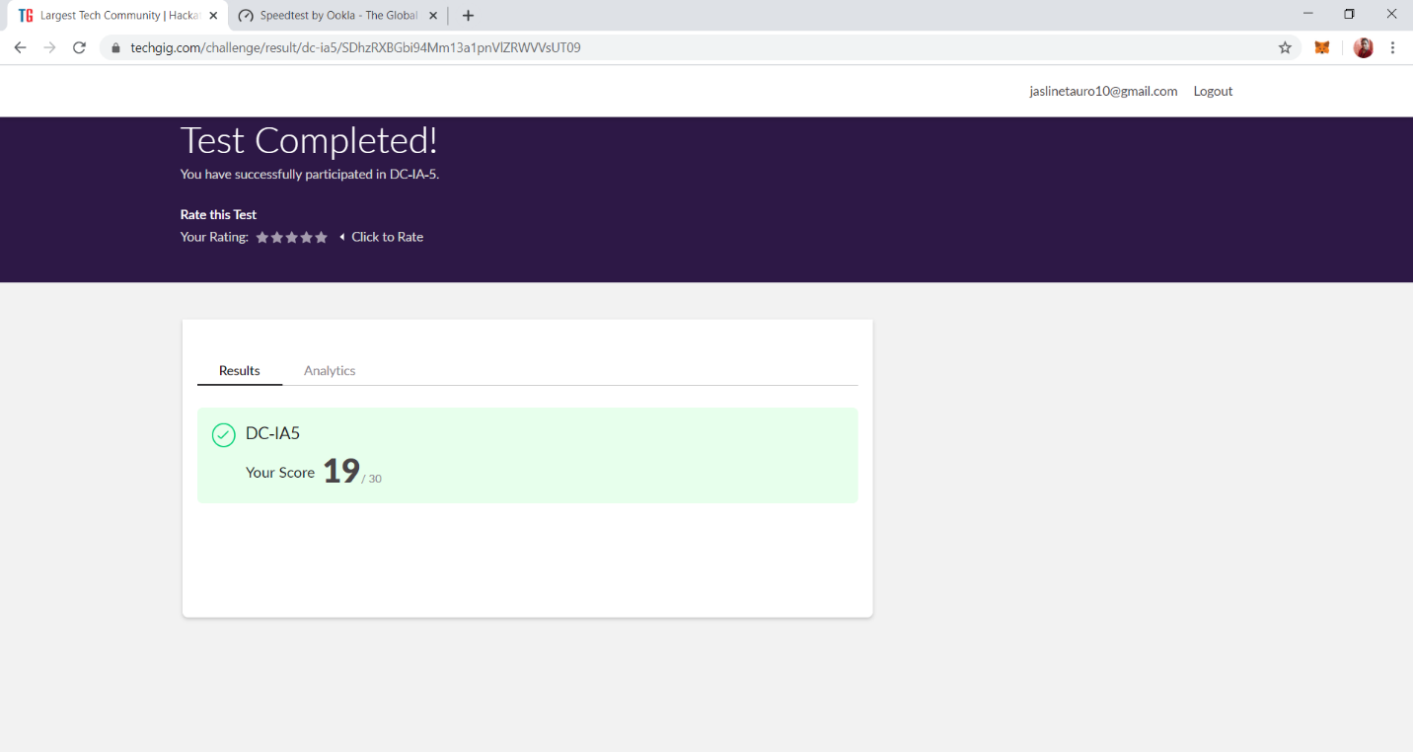

CERTIFICATION COURSE DETAILS:

Today I have started the new course “Software Developer Engineer” by AWS Educate. In this course today I learnt about the ‘Introduction of Software Development’ and about ‘Software Development Process and Methodologies’.

Today I have completed two modules of this course. And I have also completed the assessment of this course.

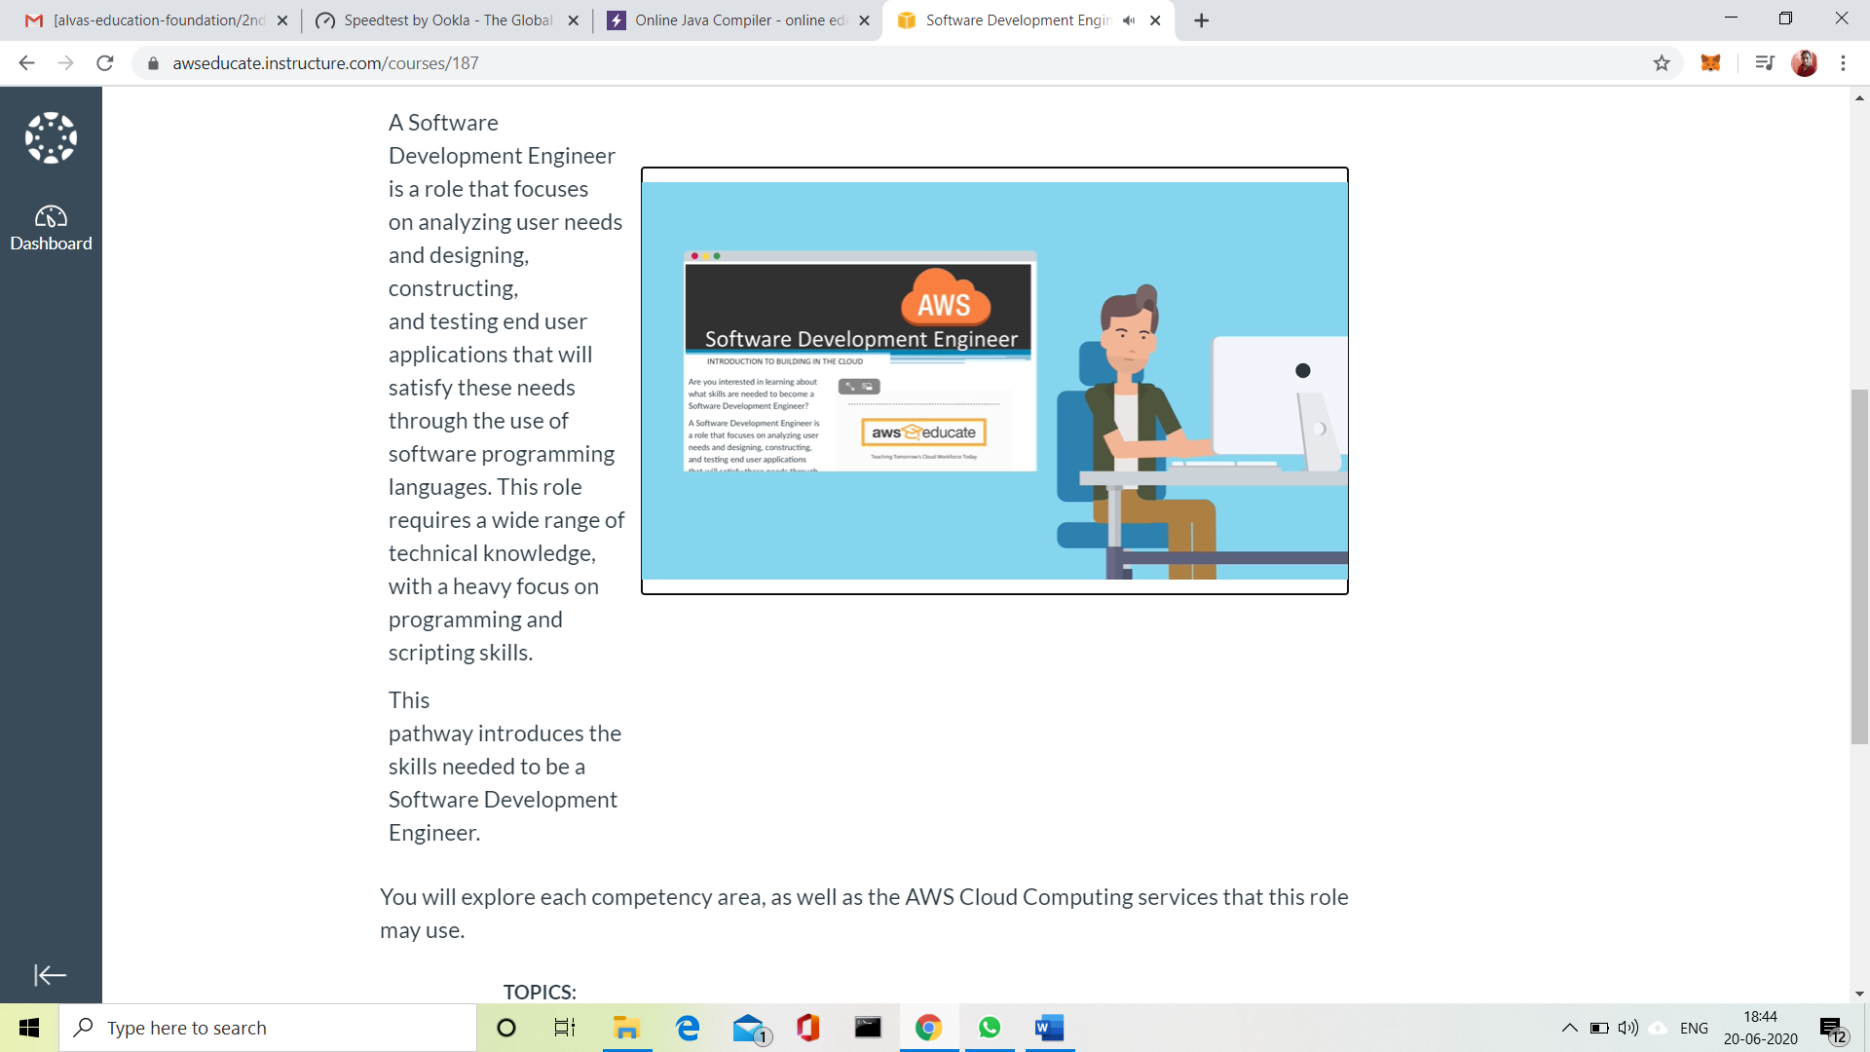

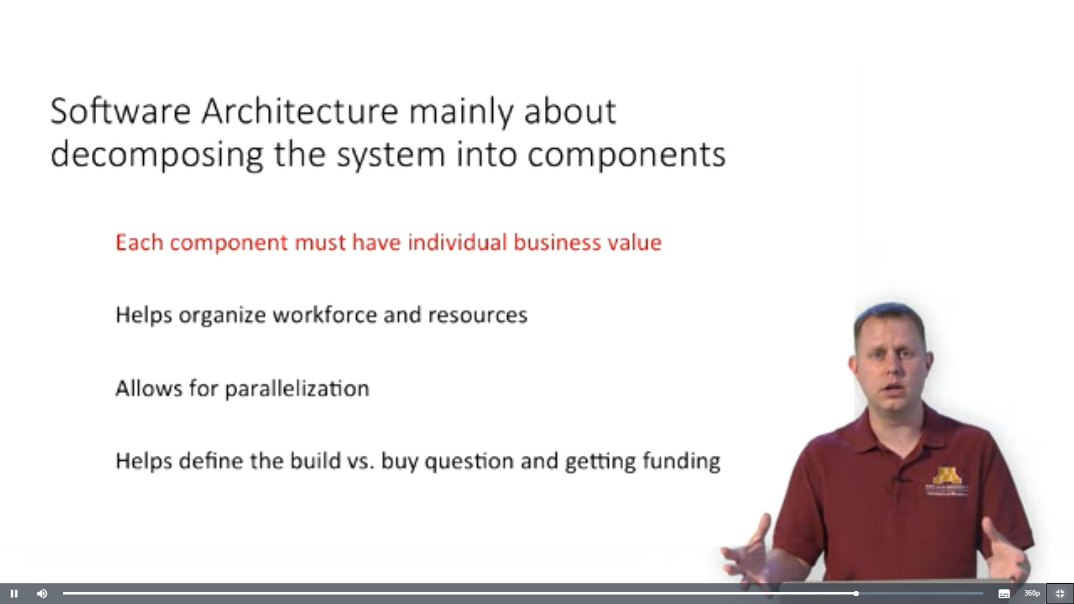

3.CODING CHALLENGES:

Problem Statement 1:

Write a Java program to count number of bits to be flipped to convert A to B.

Given two numbers ‘a’ and b’. Write a program to count number of bits needed to be flipped to convert ‘a’ to ‘b’.  
**Example:**

Input: a = 10, b = 20  
Output: 4  
Binary representation of a is 000**0101**0  
Binary representation of b is 00010100  
We need to flip highlighted four bits in a  
to make it b.

Input: a = 7, b = 10  
Output: 3  
Binary representation of a is 0000**01**1**1**  
Binary representation of b is 00001010  
We need to flip highlighted three bits in a  
to make it b.

**Hint**

1. Calculate XOR of A and B.  
   a_xor_b = A ^ B
2. Count the set bits in the above  
   calculated XOR result.  
   countSetBits(a_xor_b)

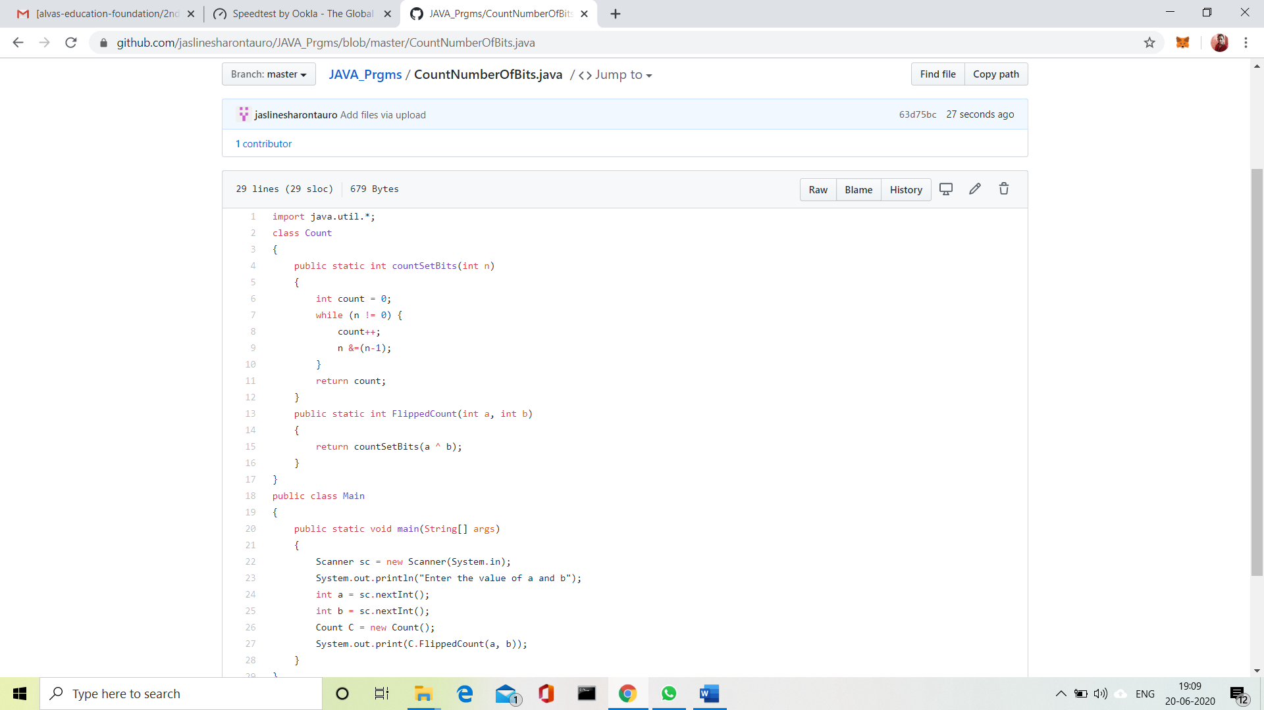

 Solution uploaded in GitHub.

Problem Statement 2:

Write a C Program to rotate an array by K positions.

Circular array rotation means rotating the elements in the array where one rotation operation moves the last element of the array to the first position and shifts all remaining elements to the right.

For example, consider the following array = [4, 5, 6],  
• Initial array [4, 5, 6]  
• After one rotation [6, 4, 5]  
• After two rotations [5, 6, 4]

OUTPUT

Element at index 0: 5  
Element at index 1: 6  
Element at index 2: 4

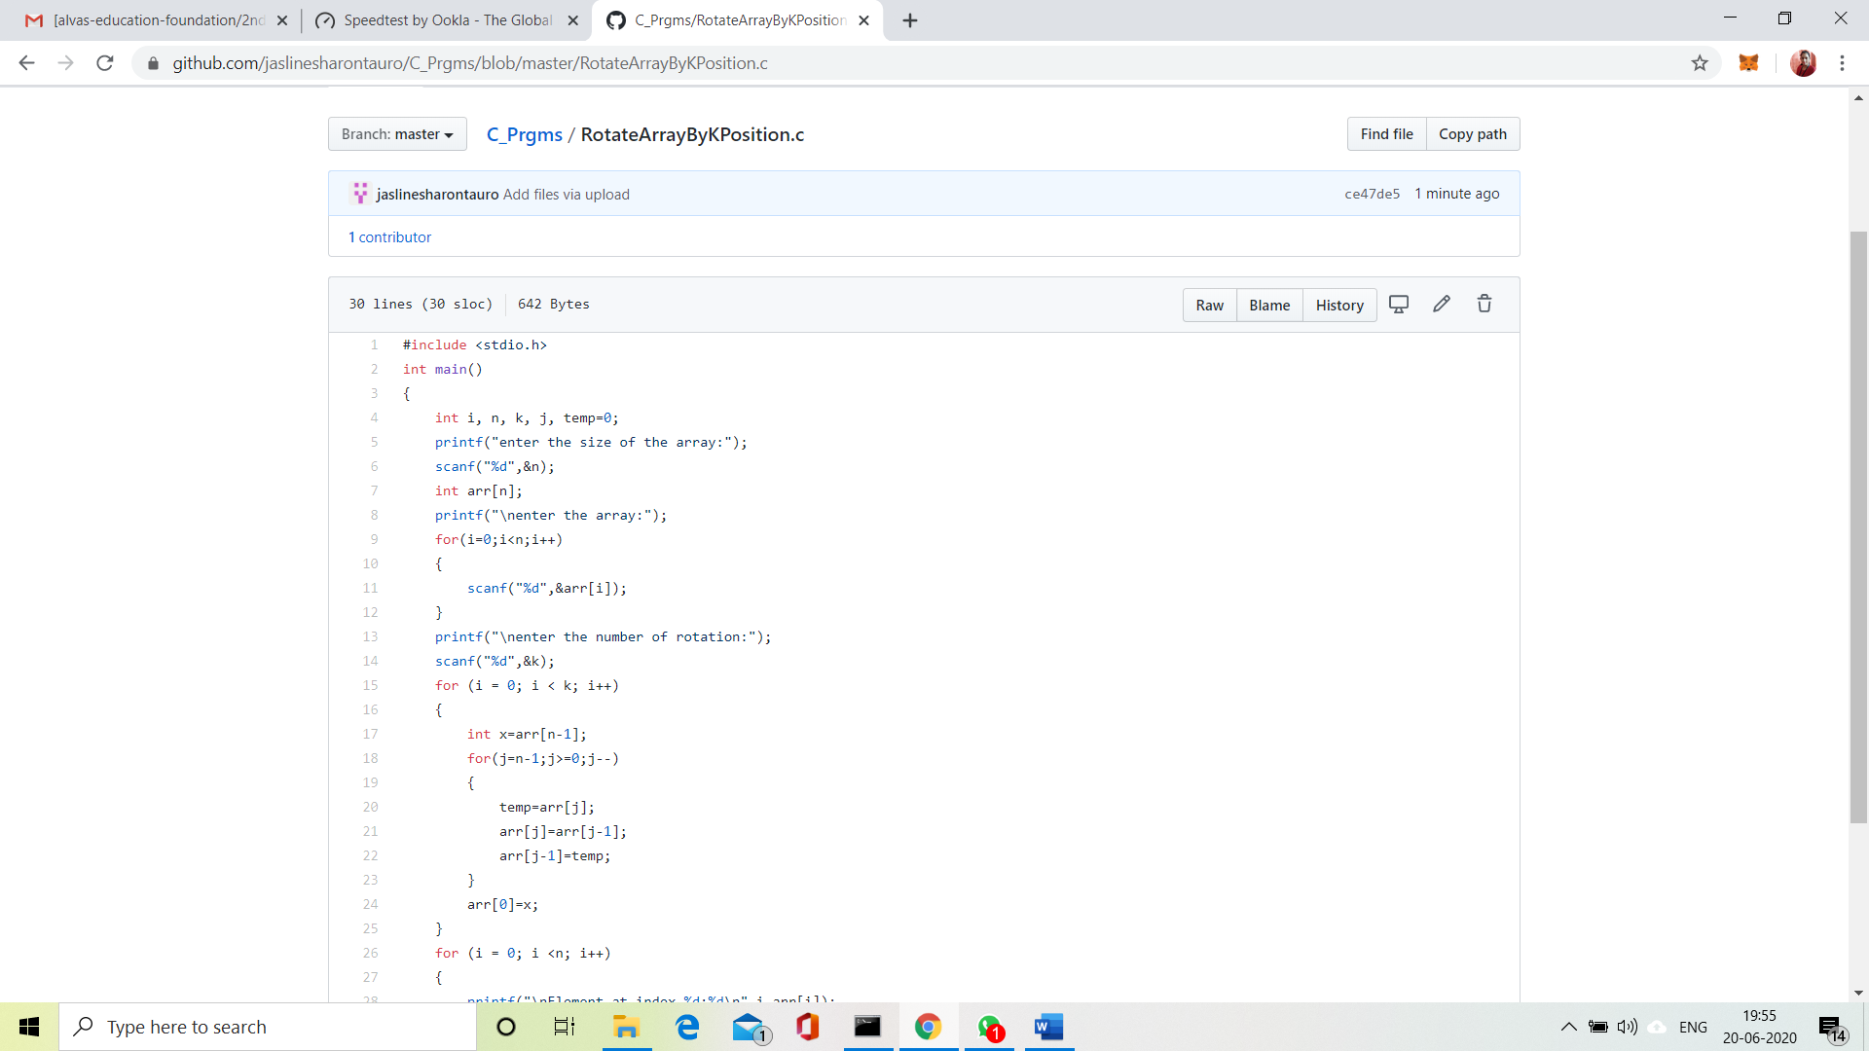

Solution uploaded in GitHub.